Test Case: tc002_SPX_Dev5_Crear_Requisicion_Spot_Con_FAD_Tipo_Cobro_CC
Step 1 - Enter username and password and click to button Enter : Credentials Entered
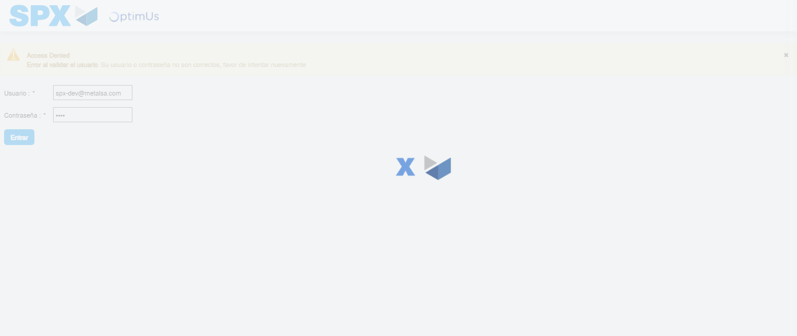Image file-name: QC_Testing-tc002_SPX_Dev5_Crear_Requisicion_Spot_Con_FAD_Tipo_Cobro_CC-1785960353351

Step 2 - Select to UEN and Access to Spot Buy Requisitions : UEN Correctly selected and Correct access
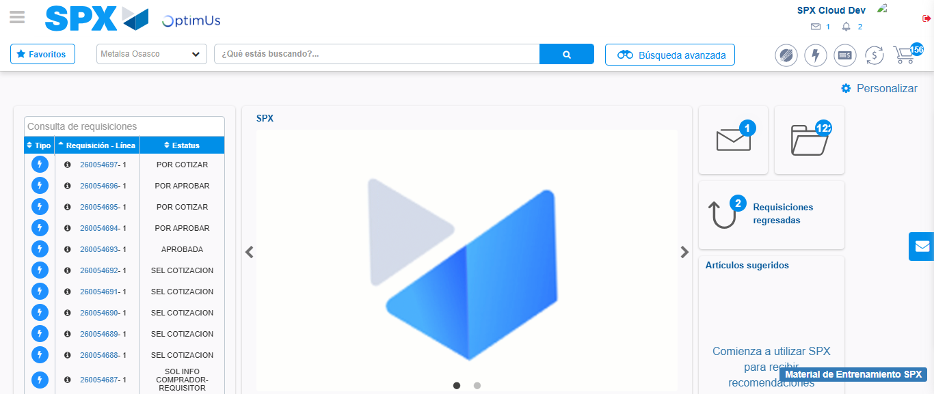Image file-name: QC_Testing-tc002_SPX_Dev5_Crear_Requisicion_Spot_Con_FAD_Tipo_Cobro_CC-1785960380171

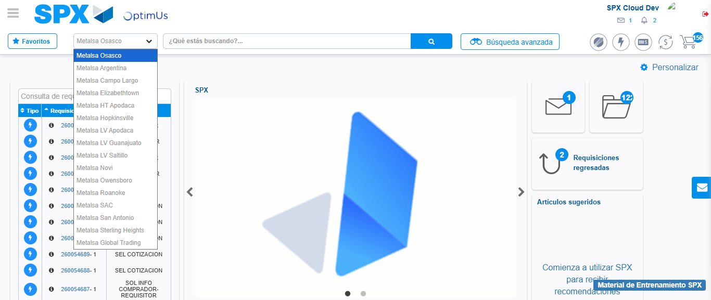Image file-name: QC_Testing-tc002_SPX_Dev5_Crear_Requisicion_Spot_Con_FAD_Tipo_Cobro_CC-1785960383050

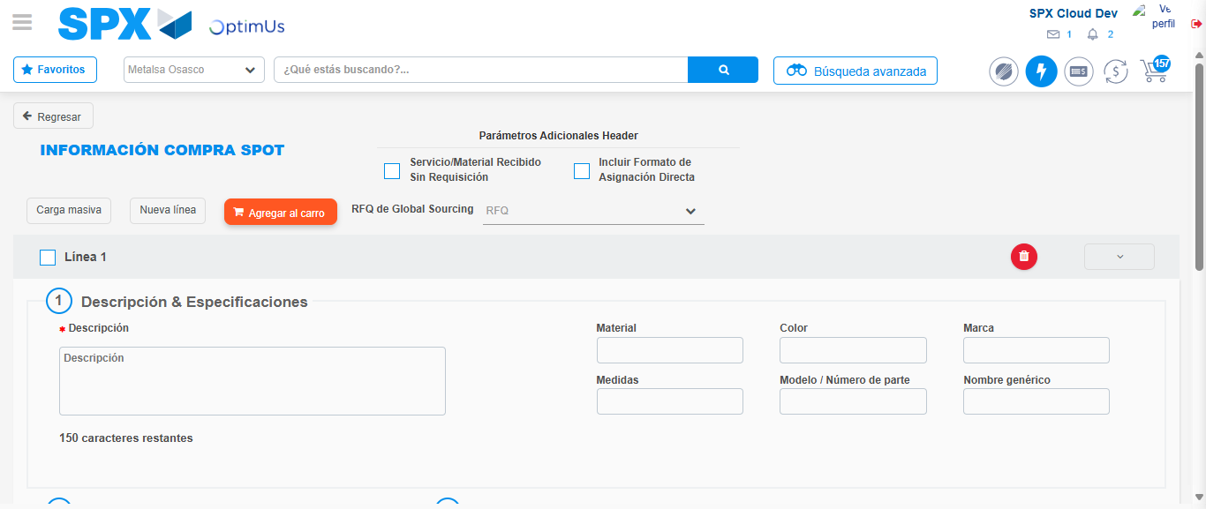Image file-name: QC_Testing-tc002_SPX_Dev5_Crear_Requisicion_Spot_Con_FAD_Tipo_Cobro_CC-1785960388702

Step 3 - Add FAD to Requisition: FAD Successfully Added
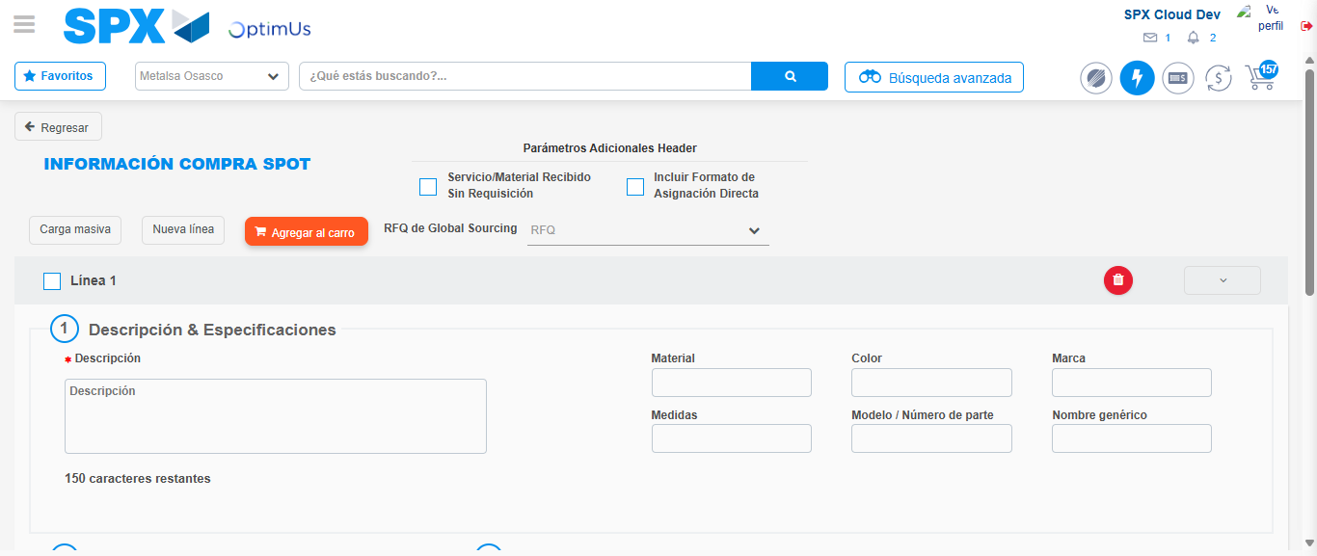Image file-name: QC_Testing-tc002_SPX_Dev5_Crear_Requisicion_Spot_Con_FAD_Tipo_Cobro_CC-1785960388986

Image file-name: QC_Testing-tc002_SPX_Dev5_Crear_Requisicion_Spot_Con_FAD_Tipo_Cobro_CC-1785960389230

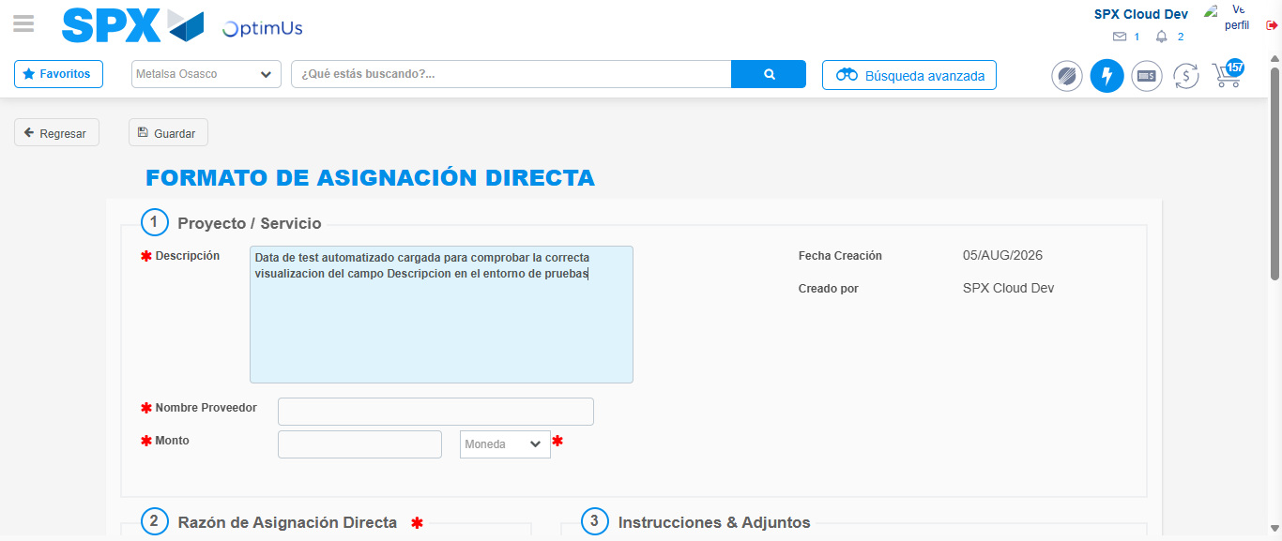Image file-name: QC_Testing-tc002_SPX_Dev5_Crear_Requisicion_Spot_Con_FAD_Tipo_Cobro_CC-1785960392262

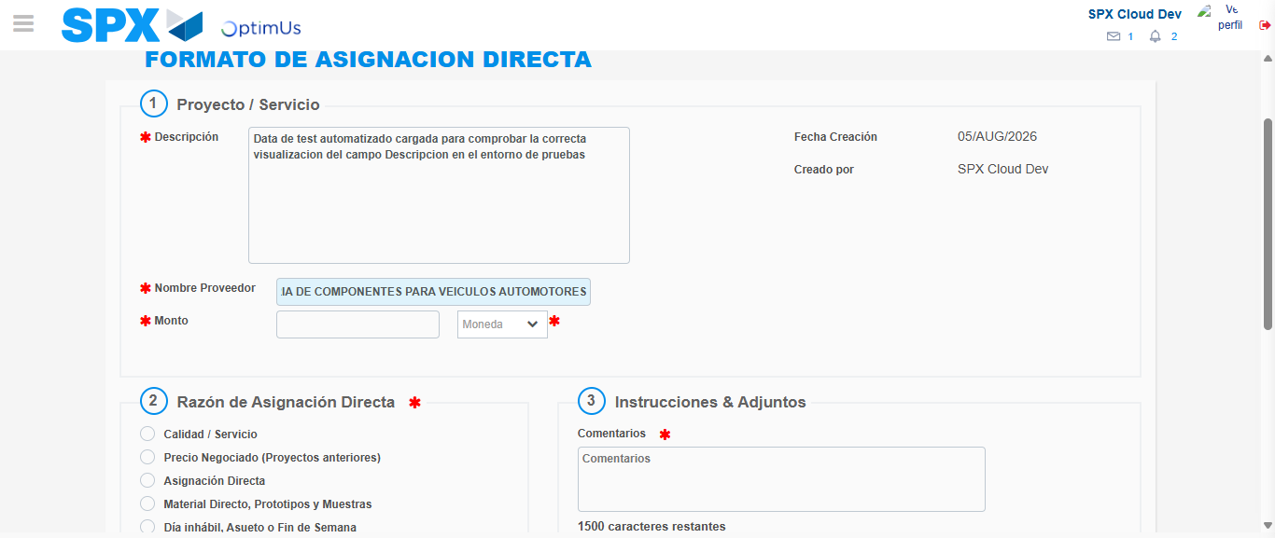Image file-name: QC_Testing-tc002_SPX_Dev5_Crear_Requisicion_Spot_Con_FAD_Tipo_Cobro_CC-1785960402362

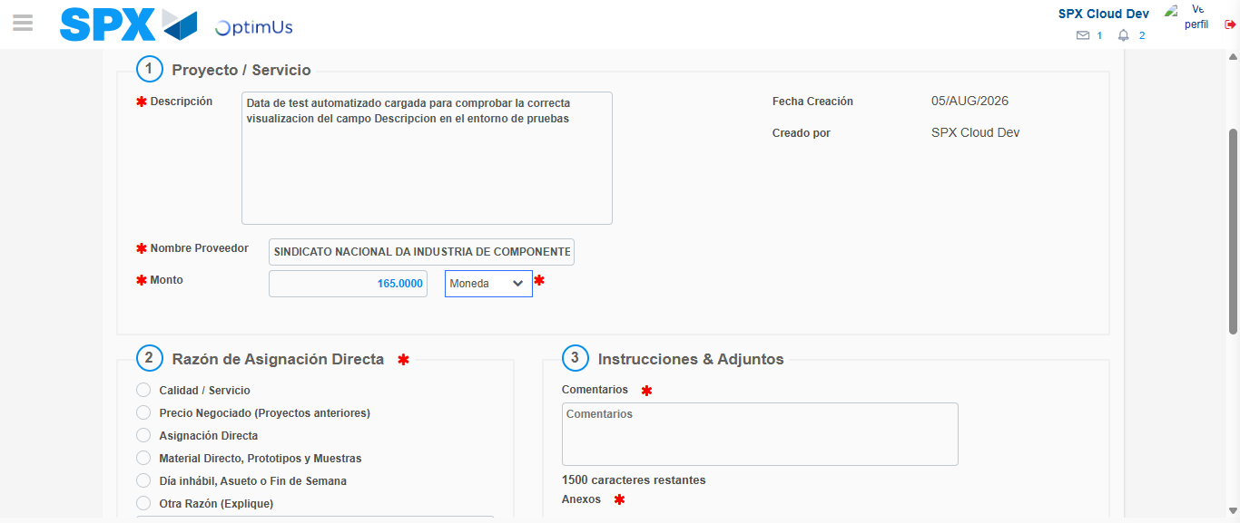Image file-name: QC_Testing-tc002_SPX_Dev5_Crear_Requisicion_Spot_Con_FAD_Tipo_Cobro_CC-1785960402751

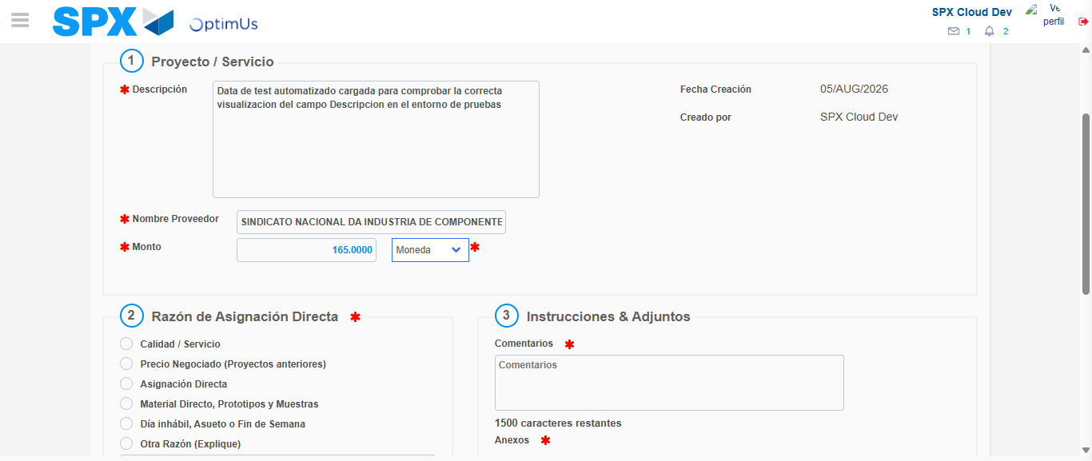Image file-name: QC_Testing-tc002_SPX_Dev5_Crear_Requisicion_Spot_Con_FAD_Tipo_Cobro_CC-1785960402921

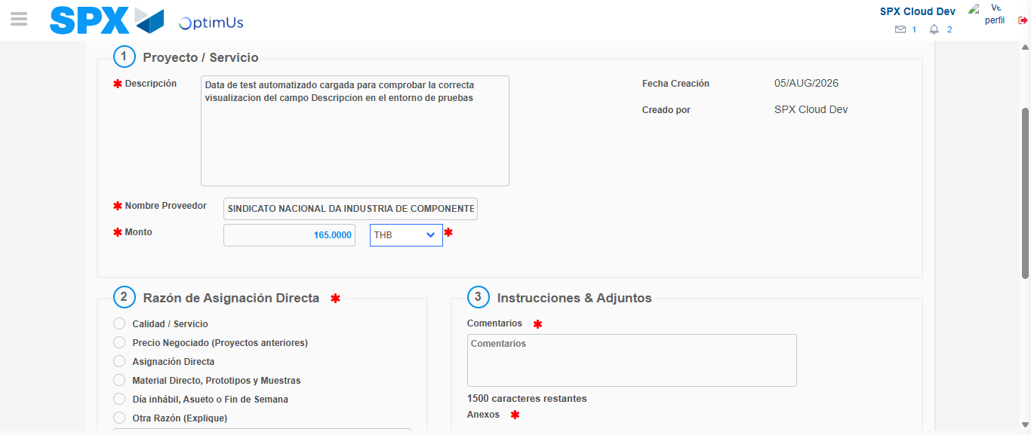Image file-name: QC_Testing-tc002_SPX_Dev5_Crear_Requisicion_Spot_Con_FAD_Tipo_Cobro_CC-1785960403231

Image file-name: QC_Testing-tc002_SPX_Dev5_Crear_Requisicion_Spot_Con_FAD_Tipo_Cobro_CC-1785960403400

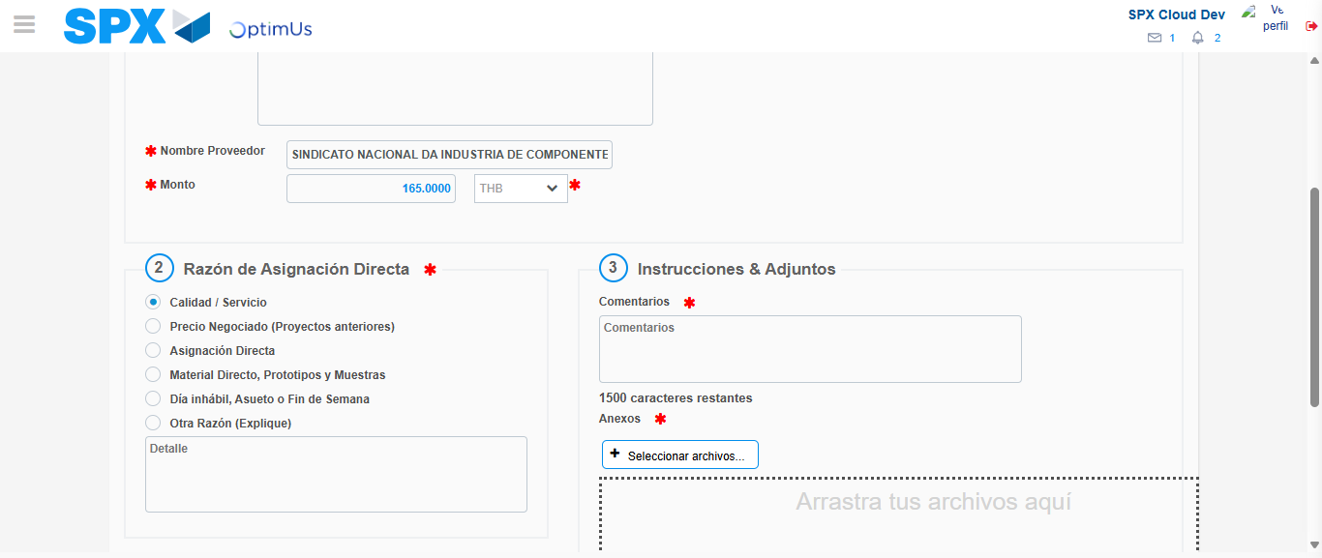Image file-name: QC_Testing-tc002_SPX_Dev5_Crear_Requisicion_Spot_Con_FAD_Tipo_Cobro_CC-1785960404216

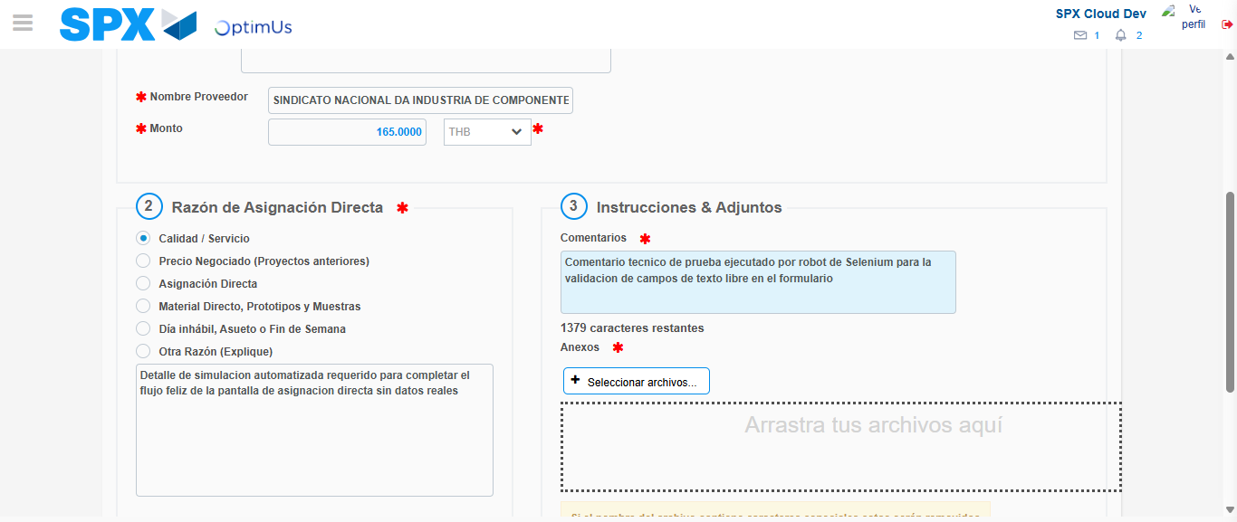Image file-name: QC_Testing-tc002_SPX_Dev5_Crear_Requisicion_Spot_Con_FAD_Tipo_Cobro_CC-1785960415223

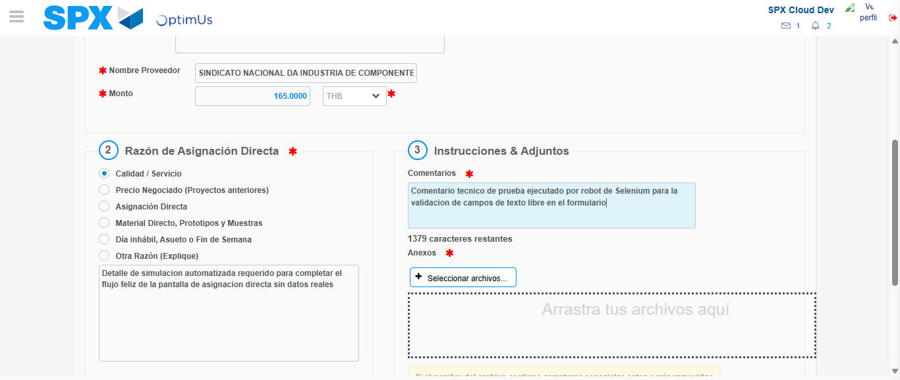Image file-name: QC_Testing-tc002_SPX_Dev5_Crear_Requisicion_Spot_Con_FAD_Tipo_Cobro_CC-1785960415866

Step 4 - Data Capture Spot Buy Requisition: Data captured correctly
Image file-name: QC_Testing-tc002_SPX_Dev5_Crear_Requisicion_Spot_Con_FAD_Tipo_Cobro_CC-1785960388986

Image file-name: QC_Testing-tc002_SPX_Dev5_Crear_Requisicion_Spot_Con_FAD_Tipo_Cobro_CC-1785960389230

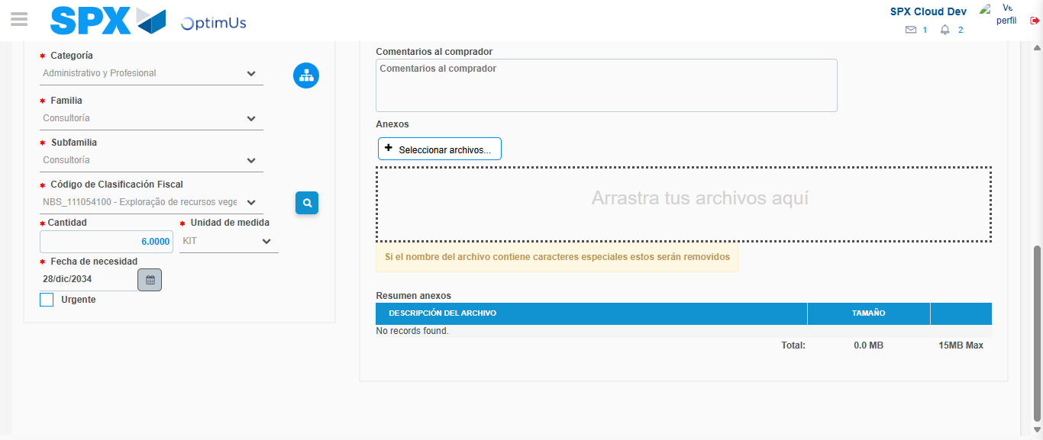Image file-name: QC_Testing-tc002_SPX_Dev5_Crear_Requisicion_Spot_Con_FAD_Tipo_Cobro_CC-1785960432055

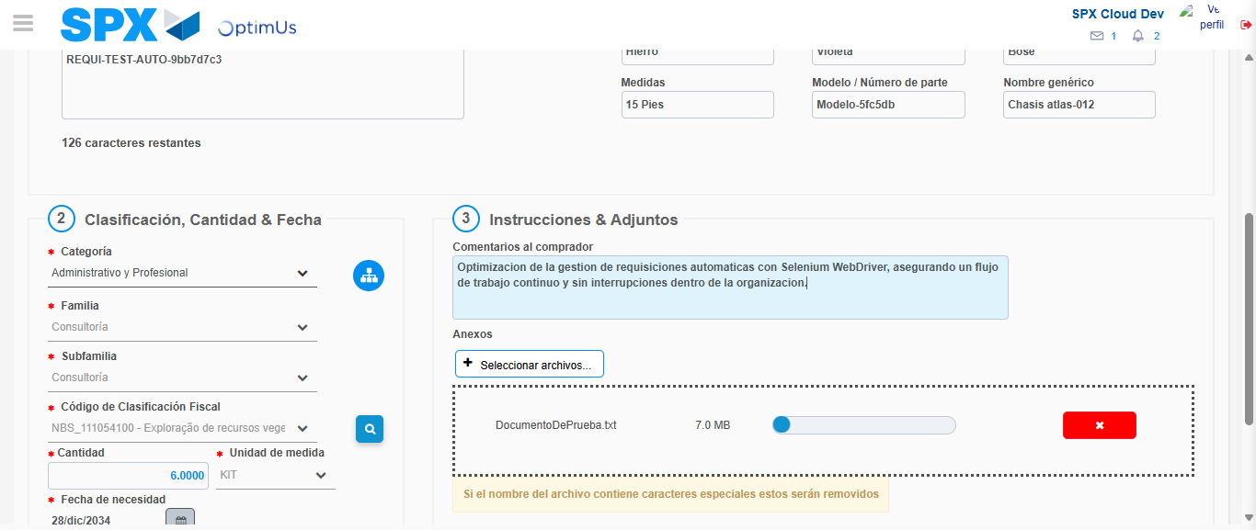Image file-name: QC_Testing-tc002_SPX_Dev5_Crear_Requisicion_Spot_Con_FAD_Tipo_Cobro_CC-1785960432800

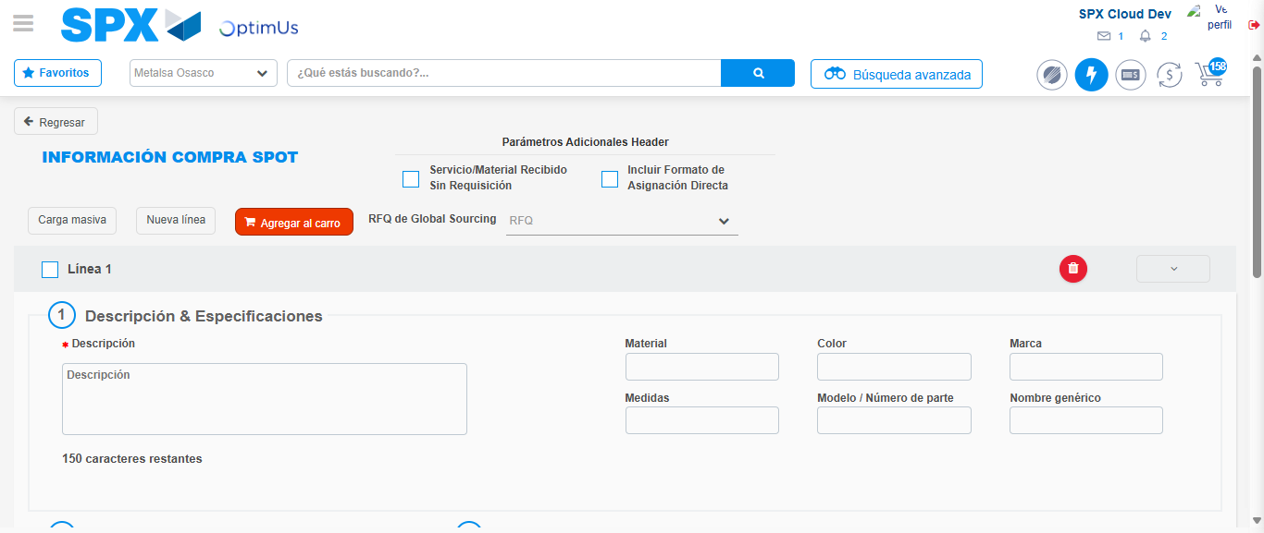Image file-name: QC_Testing-tc002_SPX_Dev5_Crear_Requisicion_Spot_Con_FAD_Tipo_Cobro_CC-1785960437768

Step 8 - Return to Main Page SPX : Return to Main Page SPX
Image file-name: QC_Testing-tc002_SPX_Dev5_Crear_Requisicion_Spot_Con_FAD_Tipo_Cobro_CC-1785960380171

Image file-name: QC_Testing-tc002_SPX_Dev5_Crear_Requisicion_Spot_Con_FAD_Tipo_Cobro_CC-1785960383050

Image file-name: QC_Testing-tc002_SPX_Dev5_Crear_Requisicion_Spot_Con_FAD_Tipo_Cobro_CC-1785960388702

Image file-name: QC_Testing-tc002_SPX_Dev5_Crear_Requisicion_Spot_Con_FAD_Tipo_Cobro_CC-1785960439994

Image file-name: QC_Testing-tc002_SPX_Dev5_Crear_Requisicion_Spot_Con_FAD_Tipo_Cobro_CC-1785960440176

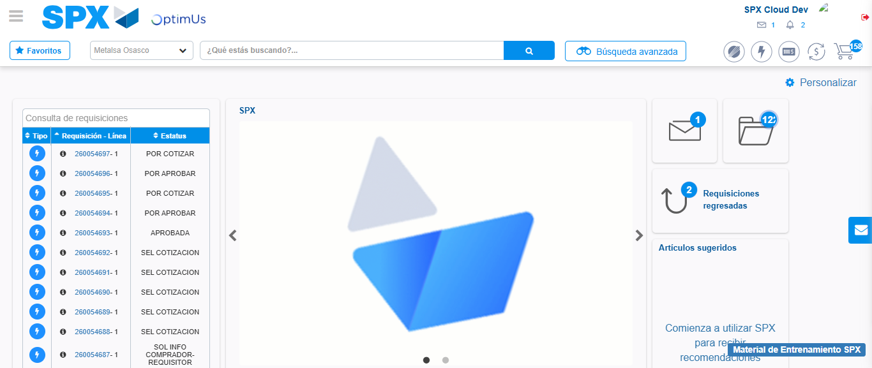Image file-name: QC_Testing-tc002_SPX_Dev5_Crear_Requisicion_Spot_Con_FAD_Tipo_Cobro_CC-1785960461336

Step 9 - Log Out : Log Out SPX
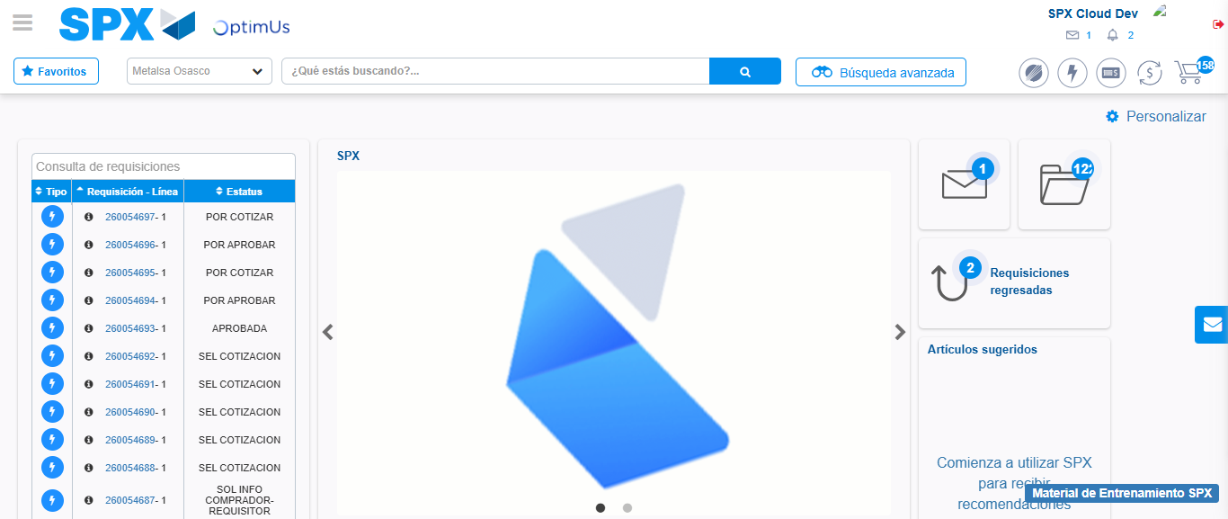Image file-name: QC_Testing-tc002_SPX_Dev5_Crear_Requisicion_Spot_Con_FAD_Tipo_Cobro_CC-1785960461627

